Minimize chunks

After analyzing the project one of the problemes was that we have big chunks, in this article we will sea some ways to fix big chunks. Let’s start:

This is the analyzing of our chunks:

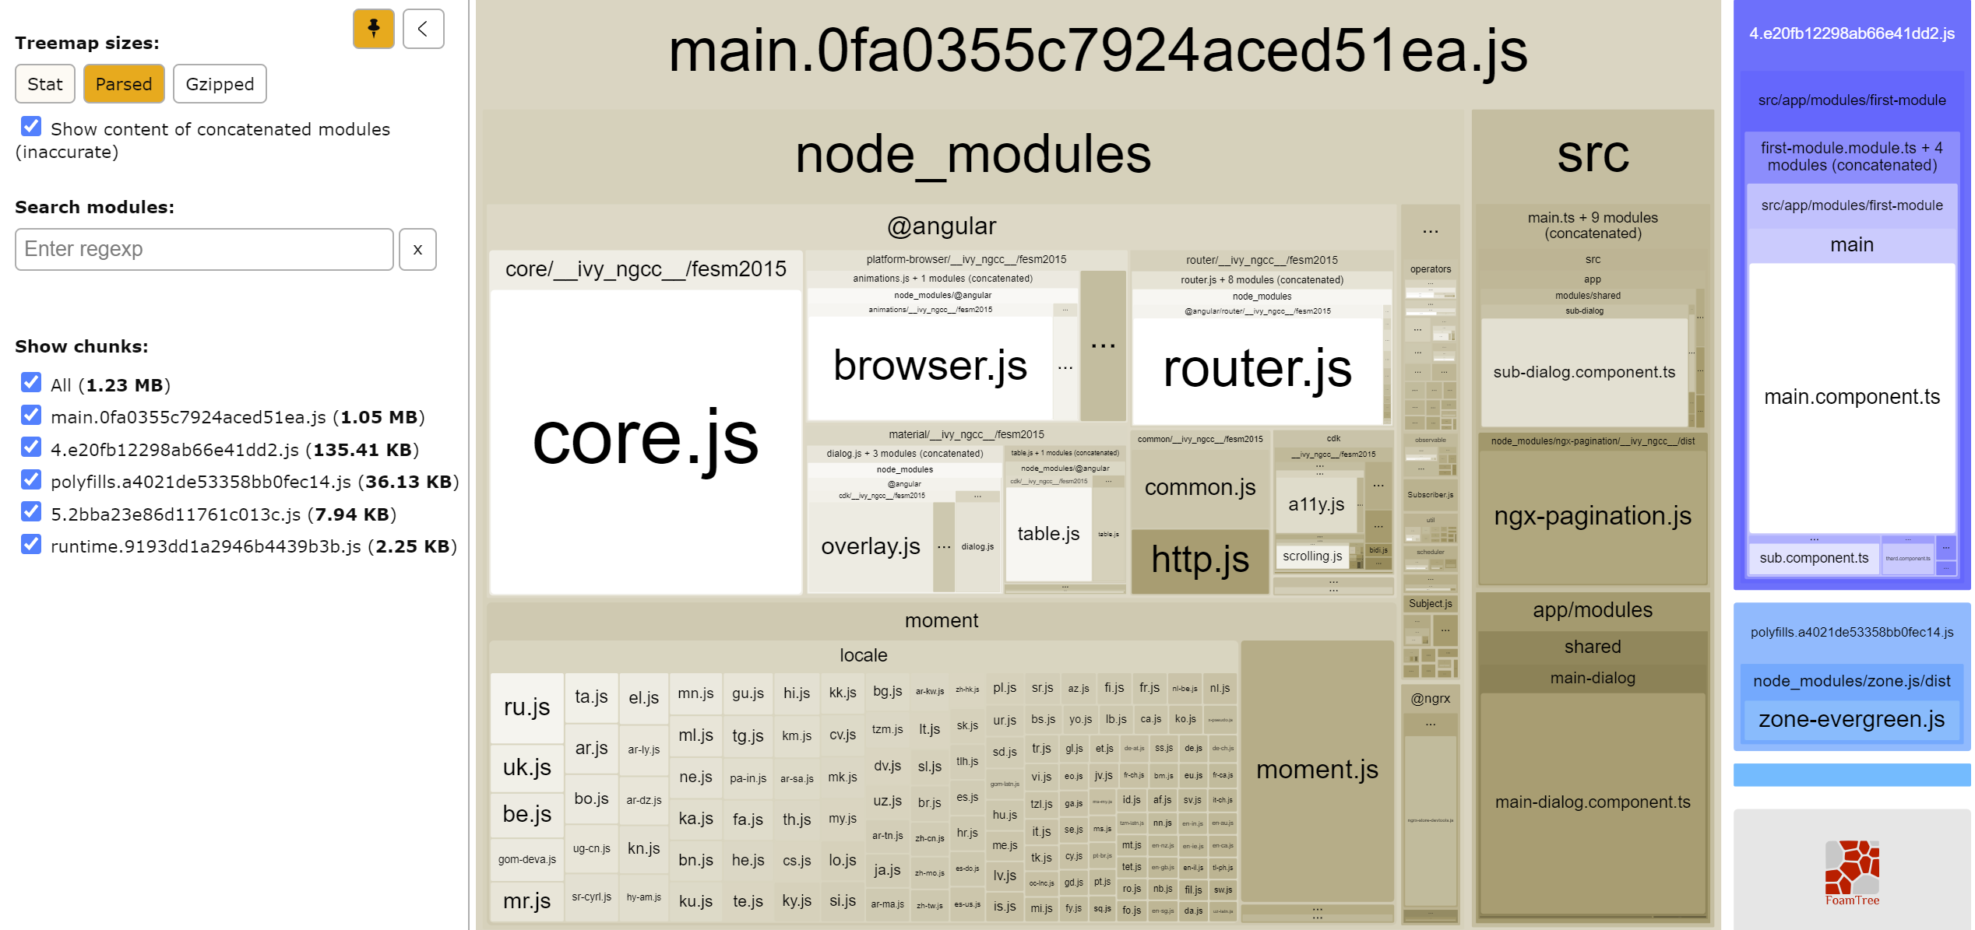

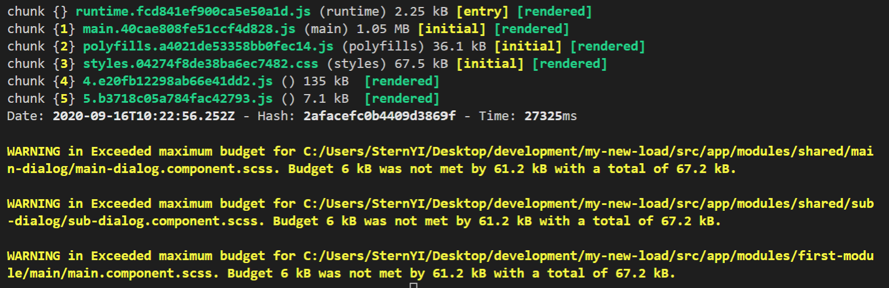

First step – lazy loading

The most easy step is last loading. Because the chages that are needed are not so big and it is very effective so this will be the fisr action

